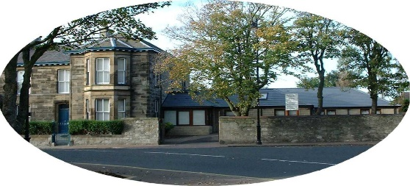

***Station Road Medical Practice***

**Policy on Non-NHS Services**

**Why do GP Practices charge fees?**

It is important to understand that many GPs are not employed by the NHS. They are self‑employed and they have to cover their costs in the same way as any small business. The NHS covers costs for NHS work, but for non-NHS work, fees are chargeable by GPs.

**What is covered by the NHS & what is not?**

The Government contract with GPs covers medical services to NHS patients, including the provision of ongoing medical treatment. However, GPs can also be involved in a whole range of non‑medical work.

Sometimes the only reason that GPs are asked is because they are in a position of trust in the community, or because an insurance company or employer wants to ensure that information provided to them is true and accurate.

Examples of non-NHS services for which GPs can charge their own NHS patients:

* Letters of support
* Insurance claim forms
* Firearms certificates

Examples of non-NHS services for which GPs can charge other organisations:

* Medical reports for insurance companies.
* Reports for Social Security Scotland/DWP in connection with disability benefits.
* Medical reports for local authorities or employers.
* Power of Attorney/Guardianship/Capacity Assessments.

**Do GPs have to do non-NHS work for patients?**

With certain limited exceptions, for example a GP confirming that one of their patients is not fit for jury service, GPs do not have to carry out non-NHS work on behalf of their patients.

Whilst GPs will always attempt to assist their patients with the completion of forms, for example for insurance purposes, they are not required to do such non-NHS work.

**Why can it take my GP a long time to complete my form?**

Time spent completing forms and preparing reports takes the GP away from the medical care of their patients.

GPs have a very heavy workload and paperwork takes up an increasing amount of their time, so many GPs find they have to take some paperwork home at night and weekends.

Our turnaround time for non-NHS work is 1 week.

**I only need a GP signature - what is the problem?**

When a GP signs a certificate or completes a report, it is a condition of remaining on the Medical Register that they only sign what they know to be true.

In order to complete even the simplest of forms, the GP might have to check the patient's entire medical record.

**What is not covered**

Not all documents require a GP signature, for example passport applications. You can ask another person in a position of trust to sign such documents free of charge.

Letters for housing and PIP applications are not required, if further information is needed, they will write to us directly for this.

HGV medicals are not currently carried out by the practice due to high demand for appointments. These can be arranged through other companies at a reduced cost e.g.:

Westburn Medical Practice, Falkirk, Tel: 01324 623577

Fit to Drive Medicals, Springburn, Tel: 0141 4065469

**What will I be charged?**

A list of fees for non-NHS Services is attached.

For a non-NHS service request, please complete the attached form and hand in to the practice or email the form to: SRMP@aapct.scot.nhs.uk

When signing the form, you are accepting responsibility of the applied fee.

Please note, this is a practice policy, individual GPs do not have the ability to waive fees.

**Station Road Medical Practice**

**Fees for Non-NHS Services**

|  |  |
| --- | --- |
| Brief Letter of Support/Information | £30 |
| Private Sicknote | £30 |
| Medical Report | £170 |
| iGPR Report | £100 |
| Firearms Form | £100 |
| Travel Insurance Claim Form | £80 |
| POA/Guardianship/Capacity Assessment | £150 |
| POA/Guardianship/Capacity Assessment with Home Visit | £200 |
| Confirmation of Changes Following Guardianship | £50 |
| Private Consultation (for Non-NHS Services) | £80 |
| Private Home Visit (for Non-NHS Services) | £120 |
| Private Blood Test (for Non-NHS Services) | £50* |
| Private Prescription (for Non-NHS Services) | £20** |
|  |  |

**\* Please note, private blood test will also carry a charge direct from the lab**

**\*\* Please note, private prescription will also carry a charge direct from the pharmacy**

**Station Road Medical Practice**

**Request for Non-NHS Services**

|  |  |
| --- | --- |
| **Full Name:** |  |
| **Date of Birth:** |  |
| **Mobile No:**  *(in case GP needs further information)* |  |
| **GP:** |  |
| **Details of Request:** *(please provide as much detail as possible)* |  |
| **Date of Request:**  *(turnaround time 1 week)* |  |
| **Signature:** |  |

**BY SIGNING THIS FORM, YOU ARE ACCEPTING RESPONSIBILITY**

**FOR THE APPLIED FEE**