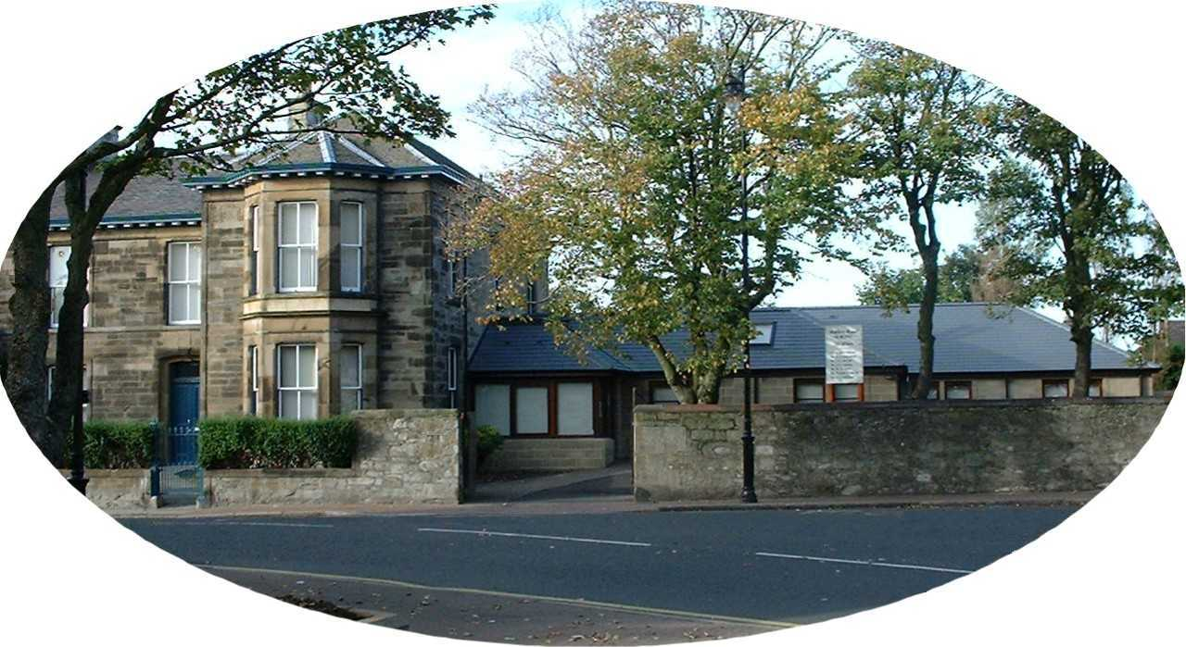

Policy on Complaints

Station Road Medical Practice is committed to providing high quality treatment to patients through the delivery of safe, effective and person-centred care. We understand, however, that sometimes things go wrong. If you are dissatisfied with something, please tell us and we will do our best to put things right. If we cannot resolve matters in the way you want, we will explain why it’s not possible to do as you suggest.

What is a Complaint?

We regard a complaint as any expression of dissatisfaction about our action or lack of action, or about the standard of service provided by us, or on our behalf.

Who Can Complain?

Anyone can make a complaint to us. You can complain directly to us, or if you would rather have someone make the complaint on your behalf, we can deal with your representative. This could be a relative, a carer, a friend or any other person that you choose. You can use patient advocacy services to help you make your complaint. If you agree to someone making the complaint on your behalf, it is important for you to know that we will need to ask for your permission for us to deal with that person.

What Can I Complain About?

You can complain about things like:

- Your care and/or treatment.
- A failure to provide a service.
- An inadequate standard of service.
- A lack of information and clarity about appointments.
- Difficulty in making contact with us for appointments or queries.
- Treatment by or attitude of a member of our staff.
- Operational and procedural issues.
- Our failure to follow the appropriate process.

We realise that it is not possible to list everything that you can complain about. If you wish to complain about something that we have not listed above, we encourage you to do so.

What Can’t I Complain About?

There are some things we cannot deal with through our complaints handling procedure. These include:

- A request for a second opinion in respect of care or treatment.
- Matters relating to private healthcare or treatment.
- Matters relating to services not provided by or funded by the NHS.
- A previously concluded complaint or a request to have a complaint reconsidered where we have already given our final decision.
- A complaint that is being or has been investigated by the Scottish Public Services Ombudsman (SPSO).
- A complaint about which you have commenced legal proceedings, or have clearly stated that you intend to do so, rather than pursue the matter using our complaints procedure.

We also realise that it is not possible to list everything that you cannot complain about. If other procedures can help you resolve your concerns, we will give information and advice to help you.

How Do I Complain?

You can complain in person, by phone, in writing, or via our complaints form at our Reception desk. Your complaint should be addressed to the Practice Development Manager.

Wherever possible we encourage you to speak with a member of staff. It is easier for us to resolve complaints if you make them quickly and directly. Staff will always try to resolve any problems on the spot if it is possible to do so.

When complaining, please tell us:

- Your name, address and date of birth.
- The name, address and date of birth of the person affected if complaining on behalf of someone else.
- As much as you can about the complaint.
- What has gone wrong.
- When did this happen.
- How you wish us to resolve the matter.

Giving us this information will help us to clearly identify the problem and what we need to do to resolve matters.

How Long do I Have to Make a Complaint?

Normally, you must make your complaint within six months of:

- The event you wish to complain about.
- Finding out that you have a reason to complain, but no longer than 12 months after the event itself.

In exceptional circumstances, we may be able to accept a complaint after the time limit. If you feel that the time limit should not apply to your complaint, please tell us why. If we decide that, because of the time that has passed since the incident occurred, we cannot consider your complaint, you can ask the Scottish Public Services Ombudsman (SPSO) to review our decision.

What Happens When I Have Complained?

Our complaints procedure has two stages.

Stage One – Early Resolution

We aim to resolve complaints quickly. Where appropriate, this could mean an on the spot apology and explanation if something has clearly gone wrong and immediate action to resolve the problem.

Sometimes we will have to make some enquiries before we can respond to your complaint. We will give you our decision at Stage One in 5 working days or less, unless there are exceptional circumstances.

If we cannot resolve your complaint at this stage, we will explain why and tell you what you can do next. We might suggest that you take your complaint to Stage Two. You may choose to do this immediately or sometime after you get our initial decision.

Stage Two – Investigation

Stage Two deals with two types of complaint, those that have not been resolved at Stage One and those that are complex and require detailed investigation.

When using Stage Two we will:

- Acknowledge receipt of your complaint within 3 working days.
- Where appropriate, discuss your complaint with you to understand why you remain dissatisfied and what outcome you are looking for.
- Give you a full response to the complaint as soon as possible and within 20 working days.

If our investigation will take longer than 20 working days, we will tell you. We will agree revised time limits with you and keep you updated on progress.

What if I’m Still Dissatisfied?

If you remain dissatisfied with our decision or the way in which we have dealt with your complaint you can approach the NHS Complaints Team:

Patient Relations & Complaints Department
NHS Ayrshire & Arran
Eglinton House
Ailsa Hospital
Dalmellington Road
Ayr KA6 6AB
Telephone: 01292 513620

You can also approach the Scottish Public Services Ombudsman (SPSO):

Scottish Public Services Ombudsman
Bridgeside House
99 McDonald Road
Edinburgh
EH7 4NS
Telephone: 0800 377 7330
Website: www.spso.org.uk

The SPSO cannot normally look at:

- A complaint that has not completed our complaints procedure, so please make sure it has done so before contacting the SPSO.
- Events that happened, or that you became aware of, more than a year ago.
- A matter that has been or is being considered in court.

Getting Help to Make Your Complaint

We understand that you may be unable, or reluctant, to make a complaint yourself. We accept complaints from the representative of a person who is dissatisfied with our service as long as the person has given their permission for us to deal with that person. We can take complaints from a friend, relative, or an advocate, if you have given them your consent to complain for you.

The Patient Advice and Support Service (PASS) is an organisation that provides free and confidential advice and support to patients in relation to NHS services in Scotland. The service promotes an awareness and understanding of the rights and responsibilities of patients and can advise and support people who wish to make a complaint. Further information and contact details can be found on the PASS web site:

www.patientadvicescotland.org.uk

Station Road Medical Practice
Quick Guide to Our Complaints Procedure

Complaints Procedure

You can make your complaint in person, by phone, in writing or via our complaints form.

We have a two-stage complaints procedure. We will always try to deal with your complaint quickly. But if it is clear that the matter will need a detailed investigation, we will tell you and keep you updated on our progress.

Still Dissatisfied?

If after receiving our final decision on your complaint, you remain dissatisfied with our decision or the way we have handled your complaint, you can ask the NHS Complaints Team or the SPSO to consider it.

We will tell you how to do this when we send you our final decision.

We will tell you how to do this when we send you our final decision.
Stage One: Early Resolution

We will always try to resolve your complaint quickly, within 5 working days if we can.

If you are dissatisfied with our response, you can ask us to consider your complaint at Stage Two.
Stage Two: Investigation

We will look at your complaint at this stage if you are dissatisfied with our response at Stage One. We also look at some complaints immediately at this stage, if it is clear that they are complex or need detailed investigation.

We will acknowledge your complaint within 3 working days. We will give you our decision as soon as possible. This will be after no more than 20 working days unless there is clearly a good reason for needing more time.

